**Experiment No. 01**

**Aim: To study and implement different data types and operators in python.**

**Code:**

x = 'hello'

print(type(x))

p = 786

print(type(p))

f = 12.3

print(type(f))

l1 = [1, 'were', 76]

print(type(l1))

a = range(7)

for i in a:

    print(i,end=" ")

print(type(a))

tp = ('qwert',)

print(type(tp))

Dict = dict()

Dict = {'Name': 'devansh', 'SAP':60004220253}

print(type(Dict))

set1 = set("the World is A beautiful pLace.")

print(set1)

print(type(set1))

print(type(True))

print(type(False))

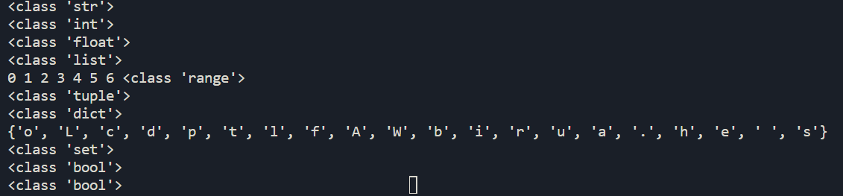**Assignment Operators:**

x = 10

print("Initial value: ",x)

x += 7

print("New value: ",x)

x -= 7

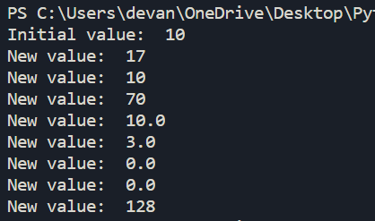print("New value: ",x)

x *= 7

print("New value: ",x)

x /= 7

print("New value: ",x)

x %= 7

print("New value: ",x)

x //= 7

print("New value: ",x)

x **= 7

print("New value: ",x)

x = 2

x **= 7

print("New value: ",x)

**Arithmetic Operators:**

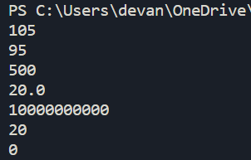x = 100

y = 5

opt = x+y

print(opt)

opt = x-y

print(opt)

opt = x*y

print(opt)

opt = x/y

print(opt)

opt = x**y

print(opt)

opt = x//y

print(opt)

opt = x%y

print(opt)

**Comparison, Logical, Identity, Membership and Bitwise Operators:**

t = 12

y = 10

x = 100

**#Comparison**

print(t==y)

print(t!=x)

print(t>=x)

print(t<=x)

**#Logical**

print(x)

print(x > 50 and x < 112)

print(x > 3 or x < 4)

print(not(x > 50 and x < 112))

**#Identity**

x = ["apple", "banana"]

y = ["apple", "banana"]

z = x

print(x is z)

print(x is y)

print(x == y)

print(x is not z)

print(x is not y)

print(x != y)

**#Membership**

print("banana" in x)

print("orange" not in x)

**#Bitwise**

print(6 & 3)

print(6 | 3)

print(6 ^ 3)

print(~3)

print(3 << 2)

print(8 >> 2)

